**Liberty University**

**CSIS 331**

**Lab 5 Answer Sheet**

Complete the table.

|  |  |  |
| --- | --- | --- |
| Device | IPv4 Default Gateway | IPv6 Default Gateway |
| ManagerA | 172.16.10.1 | FE80::1 |
| Accounting.pka | 172.16.10.1 | FE80::1 |
| ManagerB | 172.16.10.65 | FE80::1 |
| Website.pka | 172.16.10.65 | FE80::1 |

Copy and Paste R1 show run Output:

R1#show run

Building configuration...

Current configuration : 1025 bytes

!

version 15.1

no service timestamps log datetime msec

no service timestamps debug datetime msec

no service password-encryption

!

hostname R1

!

!

!

!

!

!

!

!

ip cef

ipv6 unicast-routing

!

no ipv6 cef

!

!

!

!

license udi pid CISCO2911/K9 sn FTX1524MJER

!

!

!

!

!

!

!

!

!

!

!

spanning-tree mode pvst

!

!

!

!

!

!

interface GigabitEthernet0/0

ip address 172.16.10.1 255.255.255.192

duplex auto

speed auto

ipv6 address FE80::1 link-local

ipv6 address 2001:DB8:CAFE:1::1/64

!

interface GigabitEthernet0/1

ip address 172.16.10.65 255.255.255.192

duplex auto

speed auto

ipv6 address FE80::1 link-local

ipv6 address 2001:DB8:CAFE:2::1/64

!

interface GigabitEthernet0/2

no ip address

duplex auto

speed auto

shutdown

!

interface Serial0/0/0

no ip address

encapsulation ppp

clock rate 2000000

!

interface Serial0/0/1

no ip address

clock rate 2000000

shutdown

!

interface Vlan1

no ip address

shutdown

!

ip classless

!

ip flow-export version 9

!

!

!

!

!

!

!

!

line con 0

!

line aux 0

!

line vty 0 4

login

!

!

!

end

Copy and Paste S1 show run Output:

S1#show run

Building configuration...

Current configuration : 1736 bytes

!

version 12.2

no service timestamps log datetime msec

no service timestamps debug datetime msec

no service password-encryption

!

hostname S1

!

!

!

!

!

no spanning-tree vlan 1

spanning-tree mode pvst

spanning-tree extend system-id

!

interface FastEthernet0/1

switchport mode access

!

interface FastEthernet0/2

switchport mode access

!

interface FastEthernet0/3

switchport mode access

!

interface FastEthernet0/4

switchport mode access

!

interface FastEthernet0/5

switchport mode access

!

interface FastEthernet0/6

switchport mode access

!

interface FastEthernet0/7

switchport mode access

!

interface FastEthernet0/8

switchport mode access

!

interface FastEthernet0/9

switchport mode access

!

interface FastEthernet0/10

switchport mode access

!

interface FastEthernet0/11

switchport mode access

!

interface FastEthernet0/12

switchport mode access

!

interface FastEthernet0/13

switchport mode access

!

interface FastEthernet0/14

switchport mode access

!

interface FastEthernet0/15

switchport mode access

!

interface FastEthernet0/16

switchport mode access

!

interface FastEthernet0/17

switchport mode access

!

interface FastEthernet0/18

switchport mode access

!

interface FastEthernet0/19

switchport mode access

!

interface FastEthernet0/20

switchport mode access

!

interface FastEthernet0/21

switchport mode access

!

interface FastEthernet0/22

switchport mode access

!

interface FastEthernet0/23

switchport mode access

!

interface FastEthernet0/24

switchport mode access

!

interface GigabitEthernet0/1

!

interface GigabitEthernet0/2

!

interface Vlan1

ip address 172.16.10.62 255.255.255.192

!

ip default-gateway 172.16.10.1

!

no cdp run

!

!

!

!

line con 0

!

line vty 0 4

login

line vty 5 15

login

!

!

!

!

end

Copy and Paste Screenshot of Browser showing Website.pka Manager A :

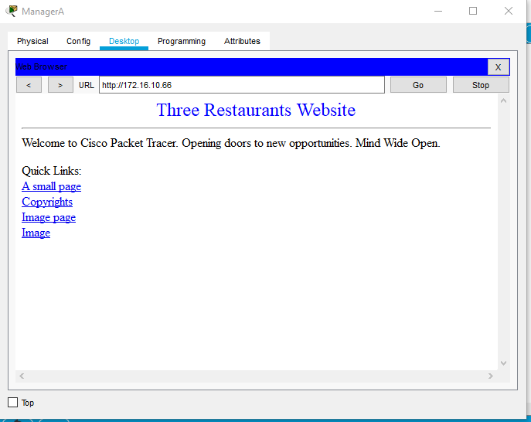

Copy and Paste Screenshot of Browser showing Website.pka Manager B :

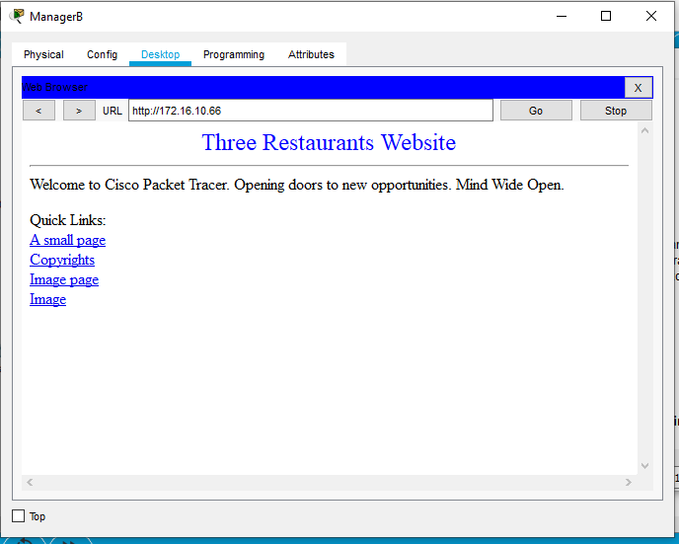

Copy and Paste Screenshot of Browser showing Accounting.pka on Manager A :

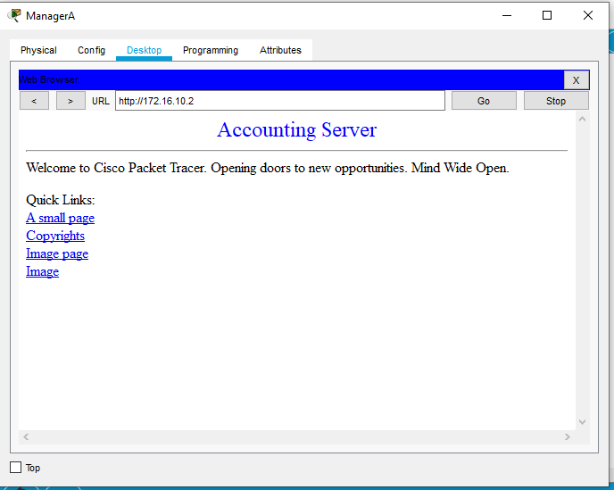

Copy and Paste Screenshot of Browser showing Accounting.pka on Manager B :

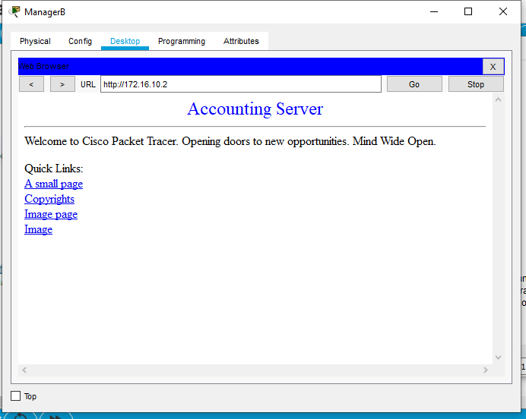

Ping Output:

|  |  |  |  |
| --- | --- | --- | --- |
| **Ping From Device IP** | **Ping to Device IP** | **Results** | **How did you resolve any errors?** |
| ManagerA | ManagerB | Data sent |  |
| ManagerB | ManagerA | Data sent |  |